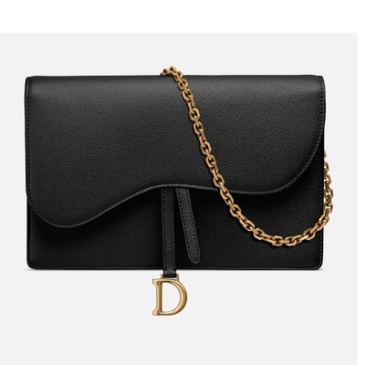

Saddle calfskin clutch

PRODUCT DETAILS

**Jewellery in aged gold-tone metal**

**Tone-on-tone suede calfskin lining**

**4 card slots**

**1 flat pocket**

**1 zipped pocket**

**Removable 120 cm chain**

**Carried in the hand, on the shoulder or across the body**

**Dimensions: 22 x 14.5 x 3.5 cm**